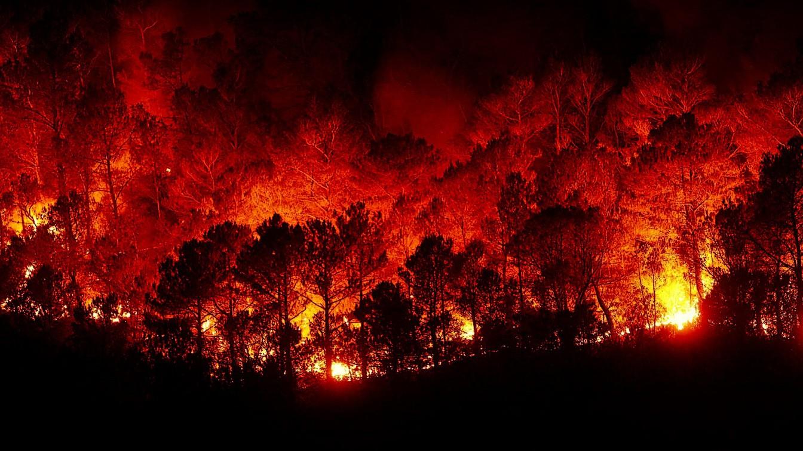

Prevents economic and ecological damage

Increases safety for humans as there is no need for involvement in detection

ML techniques are extensively employed for both prediction and detection of forest

WSN and UAV based forest fire modelling system for monitoring forest fires

Automatic detection of forest fires prevents loss of life

A forest cover map is developed with different remote- sensing techniques

Earlier detection of forest fires protects the environment

Immediate detection of fire sends a signal to the cloud and notifies emergency service

Data is collected and analyzed right on spot with sensors

Estimation of burnt areas and smoke suspended in the air are assessed

Destruction of wildlife and habitats

Increased levels of CO2

Monitoring any suspicious action in the forest

Lack of Scientific Techniques to extinguish fires

A limited amount of energy to be used for Data Processing

The application of ML techniques has its own limitations

Need for sufficient and specific conditions

Detection of forest fires quickly in real time

Potential damage and cost of fire fighting are reduced

Efficient and avoids the usage of many resources